chapter 1: Environment
Environment: everything that we see around
Environment = biotic(world of living organisms) + abiotic(world of non living elements)
natural environment = lithosphere + biosphere + hydrosphere + atmosphere
Ecosystem: It is a system formed by the interaction of all living organisms with each other and with the physical and chemical factors of the environment in which they live, all linked by transfer of energy and material.

chapter 2: Inside our earth

layers of earth:
1. crust - 35kms deep on continental surface and 5kms deep on ocean surface.
continental crust comprises of Si-Al(Sillica and Aluminium)
oceanic crust comprises of Si-Al(Sillica and Magnesium).
2. mantle - just starts under crust. 2900kms deep.
3. core - innermost layer. 3500kms deep. made of Ni-Fe(Nickel and Ferrous).

Rocks: Any natural mass of mineral matter that makes up the earth's mass are called rocks.

Types of rocks: 1. Igneous Rocks
Made of molten lava. also calld primary rocks. Two types of Igneous rocks:
1. Intrusive: formed by cooling of molten magma inside earth's crust. They form huge grains because they cool slowly. ex: granite
2. Extrusive: formed by rapid cooling down of lava on the earth's crust. ex: basalt. have fine grained structure. Deccan plateau has basalt rocks.
2. Sedimentary Rocks:
Rocks roll down, crack, and hit each other and are broken down into small fragments. These smaller particles are called sediments. These sediments are transported and deposited by wind, water, etc. These loose sediments are compressed and hardened to form layers of rocks. These types of rocks are called sedimentary rocks.
ex: sandstone
These contain fossils.
3. Metamorphic Rocks: Under great heat and pressure,
above two types of rocks convert into metamorphic.
ex: slate and marble

Chapter 3: Our changing Earth
Lithosphere is broken into number of plates called lithospheric plates. These move because of movement of lava from hotter to colder regions. The forces that act in the interior of earth are called Endogenic Forces. Exogenic forces act on the surface of the earth.
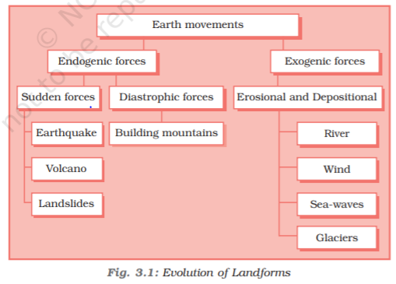

Earthquake: The place in the crust where the movement starts is called the focus. The place on the surface above the focus is called the epicentre.
There are three types of earthquake waves:
1. P waves or longitudinal waves
2. S waves or transverse waves
3. L waves or surface waves
An earthquake is measured with a machine called a seismograph. The magnitude of the earthquake is measured on the Richter scale.
Earthquake can cause things to fall if it is >= 5.0
Is considered very strong if >= 6.0
Will be classified as major earthquake if >= 7.0

Landscape is worn by two processes.
- Weathering: breaking up of rocks on earth’s surface
- Erosion: wearing away of landscape by different agents like water, wind and ice.

The highest waterfall is Angel Falls of Venezuela in South America.
Niagara waterfalls are located on the border between Canada and usa.
Victoria waterfalls are located on the borders of Zambia and Zimbabwe in Africa.
Meanders: Twists and turns formed by flowing river on a plain.
Ox bow lake: because of continuous deposition and erosion of the sides of meanders, their ends come closer and eventually cuts off from river. This is called ox bow lake.
Levees: because of flooding, soil on the banks of river gets eroded causing the inner land to be higher than river. These levelled plains are called flood plains and raised banks are called levees.
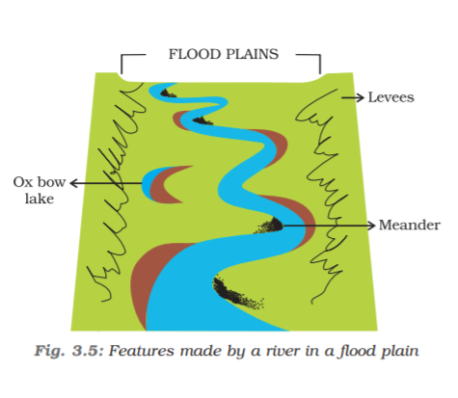
The speed of the river reduces at the sea and distributes into smaller distributaries each forming its own mouth. The collection of sediments from all the mouths forms delta.

Sea waves continuously hit massive rocks at the beaches and forms cracks in the rocks. These are called sea caves. These cavities become bigger leaving only roof on the top. These are called sea arches. Further, the erosion breaks the roof too leaving only walls. These are called stacks.
The steep rocky coast rising almost vertically above sea water is called sea cliff.

Glaciers are “rivers of ice”. The material carried by the glacier such as rocks big and small, sand and silt gets deposited. These deposits form glacial moraines.

In deserts, active agent of erosion and deposition is wind.
Wind erodes lower part of the rocks higher than upper part forming mushroom rocks.
Sand falls and deposited in low hill like structures called sand dunes.
Light and fine sand gets carried over large distances. Such deposits are called loess. Large deposits of loess can be found in china.

Chapter 4: Air
Constituents of air:
- Nitrogen: 78%
- Oxygen: 21%
- Carbon dioxide: 0.03%
- Argon: 0.93%
- All others: 0.04%
Five layers of atmosphere:
- Troposphere (upto 13kms)
- Stratosphere (upto 50kms, contains ozone)
- Mesosphere (upto 80kms, meteorites gets burned up in this layer)
- Thermosphere (80-400kms, radio transmission, radio waves gets reflected by this layer, ionosphere is part of this layer)
- Exosphere (contains helium and hydrogen)
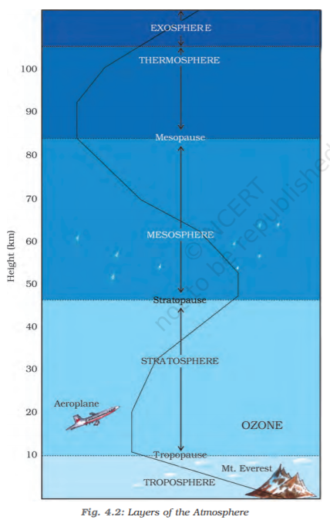
Climate: the average weather condition of a place for a longer period of time represents climate.
Insolation: incoming solar energy intercepted by the earth.
Wind vane: shows direction of wind
Rain guage: measures amount of rainfall
Barometer: measures atmospheric pressure
Thermometer: measures temperature
The air pressure is highest at sea level and decreases with height.
Low pressure is associated with cloudy skies and wet weather.
High pressure is associated with clear and sunny skies.
3 types of winds:
- Permanent winds: The trade winds, westerlies and easterlies are the permanent winds. These blow constantly throughout the year in a particular direction.
- Seasonal winds: These winds change their direction in different seasons. Ex: monsoons in India.
- Local winds: These blow only during a particular period of the day or year in a small area. For example, land and sea breeze. The hot and dry local wind of northern plains of India is called loo.
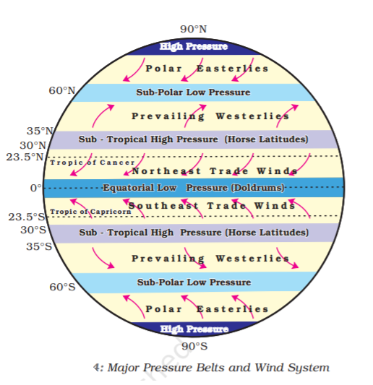
Moisture in the air at any time, is known as humidity.
3 types of rainfall:
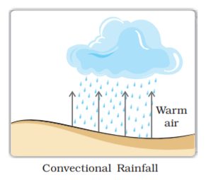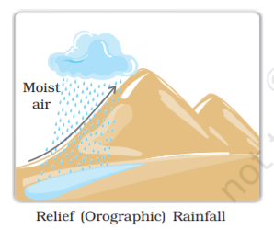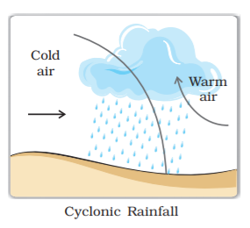

Chapter 5: Water
Terrarium: an artificial enclosure for keeping small house plants
Average salinity (no of grams of salt in 1000 grams of water) of ocean is 35 parts per thousand.
Dead sea in Israel has salinity of 340 grams per litre of water. Swimmers can float in it.
Water distribution:
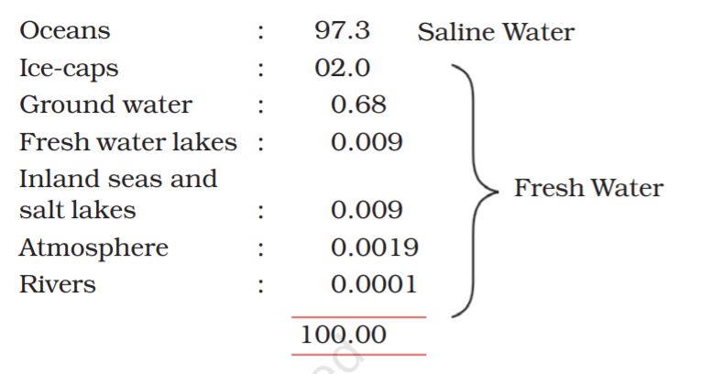
March 22: World water day
Ocean water movements are of three types:
- Waves: formed by wind scraping against ocean surface
- Tides: The rhythmic rise and fall of ocean water twice in a day is called a tide. These are caused gravitational forces by sun and moon.
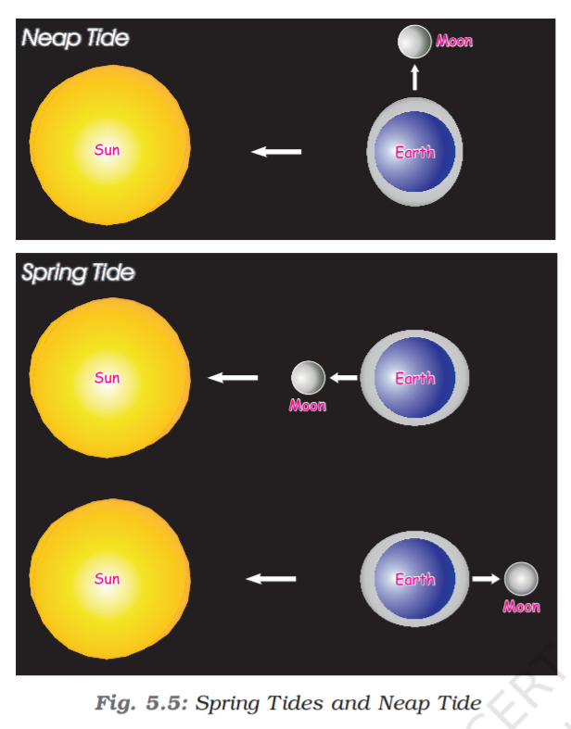
Spring tides are high tides and neap tides are low tides
- Ocean currents: Ocean currents are streams of water flowing constantly on the ocean surface in definite directions. These maybe warm or cold. Warm currents travel from equator to poles whereas reverse is true for cold currents. Ex: Labrador currents are cold currents and Gulfstream currents are warm currents. The areas where these two meet have the best conditions for fishing. Ex: japan, north America. These areas also have foggy climate which makes difficult for navigation.

Chapter 6: Natural Vegetation and Wild Life
Coniferous trees are tall, thin pointed leaves and cone shaped canopies on mountain slopes.
Natural Vegetation is three categories:
- Forests: grow where temperature and moisture are plenty to support tree cover
- Grasslands: grow in region of moderate rain
- Shrubs: Thorny shrubs and scrubs grow in the dry region
Tropical evergreen forest in brazil is so enormous that it is like the lungs of the earth.
Types of Forests:
- Tropical evergreen forests: also called as tropical rainforests. Grow in the equator and close to tropics. These regions are hot and receive heavy rainfall. No particular dry season. So, trees do not shed leaves all together. That’s why are called evergreen. Thick canopy doesn’t allow sunlight to shed on the land. Hardwood trees like rosewood, ebony, mahogany, etc., are found.
- Tropical deciduous forests: these are monsoon forests found in large part of India, northern Australia, central America. Tree shed leaves during summer season to conserve water. Hardwood trees found here are sal, teak, neem and shisam. Tigers, lions, elephants, langoors and monkeys are common animals here.
- Temperate Evergreen Forests: these are located in mid-latitudinal coastal region. Commonly found in eastern margin of the continents. Ex: south east usa, south china, south east brazil. Both hard and soft wood trees like oak, pine, eucalyptus, etc.,
- Temperate Deciduous forests: found at higher latitudes. These are found in the north eastern part of USA, China, New Zealand, Chile and also found in the coastal regions of Western Europe. They shed their leaves in the dry season. The common trees are oak, ash, beech, etc. Deer, foxes, wolves are the animals commonly found. Birds like pheasants, monals are also found here
- Mediterranean vegetation: The west and south west margins of the continents are different. They have Mediterranean vegetation. It is mostly found in the areas around the Mediterranean Sea in Europe, Africa and Asia. Can also be found in California, south west Africa, south western south America, south west Australia. These have hot dry summers and mild rainy winters. Citrus fruits like oranges, figs, olives and grapes are commonly cultivated. Natural vegetation is removed and above plants are cultivated. Also, wildlife is not found much here.
- Coniferous Forests: found in higher latitudes (50-70) of northern hemisphere. These are also called as taiga. These can also be found at higher altitudes like himalayas. They are tall, softwood evergreen trees. Can be used for making paper and newsprint, matchboxes, packing boxes. Chir, pine and cedar are the important variety of trees here. Silver fox, mink, polar bear are common animals.
Types of grasslands:
- Tropical grasslands: occur on either side of equator and extend till tropics. Moderate to low amount of rainfall. Grass can grow very tall, about 3 to 4 metres. Ex: savannah grasslands of Africa. Elephants, zebras, giraffes, deer, leopards are found.
- Temperate grasslands: found in mid-latitudinal zones and in interior part of continents. Grass here is short and nutritious. Wild buffaloes, bisons, antilopes are common.
- Thorny bushes: found in dry desert like regions. Found in west margins of the continents. Because of scanty rain and scorching heat, vegetation is very low.
Polar regions have very scarce vegetation. Only mosses, lichens and very small shrubs can be found. These grow during very short summer. This type of vegetation is called Tundra. Animals have thick fur to protect from cold. Seal, walruses, musk-oxen, arctic owl, polar bear and snow foxes can be found.

Names of the grasslands:
North America – prairies
Asia – steppes
Africa – savannahs, veldts
Australia – rangelands, pampas, llanos, downs
South America – cerrados

Chapter 7: Human Environment – Settlement, Transport and Communication
Transport is of 4 types:
- Roadways: roads are of two types: metalled (pucca) or unmetalled (kutcha). Manali-Leh highway in the Himalayan mountains is one of the highest roads in the world.
- Railways: India has the largest railway network in Asia. Trans-Siberian railway is the longest railway system connecting St. Petersburg in western Russia to Vladisvostok on the pacific coast
- Waterways: Cheapest form of transportation. Two types of waterways:
- Inland waterways: navigable rivers, lakes are inland waterways. Ex: ganga-brahmaputra river system, the great lakes in north America and the rive Nile in Africa.
- Sea Routes: these are used for transporting merchandise and goods from one country to another. Ports Ex: Singapore, Mumbai in Asia, new York, los angeles in north America, rio de janerio in south America, Durban and cape town in Africa, Sydney in Australia, London and Rotterdam in Europe.
- Airways: fastest way of transport. Developed in early 20th century. Most expensive. Can be accessed even from remote areas (helicopters). Airports Ex: delhi, Mumbai, new York, London.
Communication is the process of conveying message to others. Radio, television, newspapers are called mass media, because of their ability to communicate with large people.

Chapter 8: Human Environment Interactions: The Tropical and the Sub Tropical Region
Amazon basin:
This lies in tropical region between 10 degrees north and 10 degrees south. Amazon name is given Spanish explorers, who when visited the place got attacked by local tribes wearing headgears and grass skirts. These people reminded them of fierce tribes of women known in ancient roman empire as the Amazons. Hence the name.
Amazon basin is the largest basin in the world. Tropical Rainforests occur in this region because of heavy rains. Bromeliads are type of plants that store water in their leaves. Frogs use these pockets of water to lay eggs.
People in the amazon basin practice slash and burn agriculture. Farmers first slash the trees to clear the land. Then they burn the remains to release nutrients into the soil. They practice agriculture for few years. After soil looses its fertility, they move to another area. After some years, soil fertility is restored and can be used again.
Men hunt and fish while women take care of agriculture. Hunting and fishing are uncertain. So women feed the family by agriculture. The staple food here is manioc also known as cassava that grows under the ground like potato. They also eat queen ants and egg sacs. Cash crops like coffee, maize and cocoa are also grown. Houses here are thatched and shaped like beehives. Other large apartment like houses called maloca with steep roof are also built. Now-a-days highways and airways are built to access this basin. In old days, river ways were used to access. Deforestation in amazon basin is at alarming levels.
Ganga-Brahmaputra basin:
It lies in sub-tropical region that is situated between 10 degrees North and 30 degrees north.
Tributaries of ganga:
- Ghaghra
- Son
- Chambal
- Gandak
- Kosi
Tributaries of Brahmaputra:
- Beki
- Bhogdoi
- Dibang
- Dihing
- Duilong
- Jinai
- Kolong
- Kopili
- Lhasa
- Lohit
- Manas
- Nimu maqu
- Parlung tsangpo
- Pengbo
- Raidak
- Reting
- Subansiri
- Teesta
This area has mainly monsoon climate. It rains from mid-June to mid-september. Summers are hot and winters are cool. Main crop is paddy. Wheat, maize, sorghum, gram and millets are other crops. Cash crops like sugarcane and jute are also grown. Banana is grown in some areas. In west Bengal and assam, tea is grown in plantations. Silk is produced through cultivation of silk worms in parts of bihar and assam. In mountains and hills, where slopes are gentle, crops are grown on terraces (Terrace farming). Thick bamboo groves are common in Brahmaputra plain. Delta area is covered with mangrove forests. In Uttarakhand, Sikkim, arunachal Pradesh we find coniferous trees like pine, deodar and fir because climate is cool and slopes are steep.
Elephants, tigers, deer and monkeys are common. The one-horned rhinoceros is found in Brahmaputra plain. In the delta area, Bengal tiger, crocodiles and alligator are found. Common fish are rohu, catla and hilsa. Staple diet is fish and rice.
In fresh waters of ganga and Brahmaputra, we can find dolphins (locally called as susu or blind dolphin). The presence of these dolphins is an indication of pollution level in the rivers. To accelerate the efforts to achieve universal sanitation coverage and to put fours on sanitation, the PM of india launched Swachh Bharat Mission on 02nd oct 2014. Allahabad, Kanpur, Varanasi, lucknow, patna, Kolkata are located along the river ganga. Waste water from these cities is causing pollution in the river. All four ways of transportation are well developed in this basin. Tourism is another main aspect in this basin. Taj mahal, Buddhists stupas, Imambara (lucknow), kaziranga (assam), manas, etc., are famous tourist spots.

Chapter 9: Life in the Deserts
Deserts are of two types:
- Hot deserts
- Cold deserts

Hot Desert - Sahara:
Sahara Desert is the world’s largest desert with an area of 8.54 sq. kms. It touches 11 countries (algeria, chad, Egypt, Libya, mali, Mauritania, morocco, niger, sudan, Tunisia, western sahara). Some of the rocky surfaces are as high as 2500m. It once used to be a lush green plain with rivers, crocodiles, elephants, lions, giraffes, ostriches, sheep, cattle and goats. Change in climate has led to current situation.
Al azizia in the sahara desert, south of Tripoli, Libya recorded highest temperature of 57.7 degrees Celsius in 1922. Days may reach temperature of 50 degrees Celsius while nights reach close to zero degrees.
Vegetation includes cactus, date palms, acacia. Oasis – green islands with date palms surrounding them are also present. Camels, hyenas, jackals, foxes, scorpians, many varieties of snakes and lizards are prominent. Scientists have actually found skeletons of fish here.
Nomadic people live here such as Bedouins, tuaregs. They rear goats, sheep, camel and horses to provide them from milk, hies to make belts, slippers, water bottles, hair used for mats, carpets, clothes and blankets. They wear heavy robes as protection from dust storms and hot winds.
The oasis in the sahara and nile valley in Egypt supports settled population. People grow date palms, rice, wheat, barley, beans. Egyptian cotton is worldwide renown. Discovery of oil in Algeria, Libya and Egypt is slowly transforming the desert. Iron, phosphorous, manganese, uranium can also be found.
Depressions are formed when the wind blows sand away. Sometimes underground water reaches the surface forming oasis. Tafilalet oasis in morocco has large area of 13000 sq km.

Cold Desert – Ladakh:
Ladakh word is made up of two words – “La” means mountain pass and “dak” means country.
Drass – one of the coldest inhabited places on earth is located in Ladakh.
Located on the eastern side of jammu and Kashmir between karakoram range on the north and zankar mountains on the south. Indus flows through Ladakh. Gangri glacier is found in Ladakh. Altitude varies from 3000m at kargil to 8000m in the karakoram. Day temperatures in summer are just above zero degrees and night temperatures are well below -30 degrees. In winters temperatures may remain -40 degrees most of the time. It lies in the rain shadow of Himalayas. So, there is a very low rainfall of 10 cm every year. Freezing winds and burning hot sunlight (because of thin atmosphere). if you sit in the sun with your feet in the shade, you may suffer from both sunstroke and frost bite at the same time.
Vegetation is sparse. Scanty patches of grasses and shrubs for animals to graze. Groves of willows and poplars are seen in the valleys. In summers, apples, apricots and walnuts bloom. Birds such as robins, redstarts, tibetan snowcock, raven and hoopoe are common. Wild goats, wild sheep, yak and special kinds of dogs are found. Yak’s milk is used to make cheese and butter. Hair of sheep and goat is used to make woollens.
Pashmina wool from Kashmir is very famous around the world.
People in Ladakh are mostly either Muslims or Buddhists. Buddhists monasteris in Ladakh are called gompas. Some famous monesteris are hemis, thiksey, shey and lamayuru.
In summer season people cultivate barley, potatoes, peas, beans and turnip. The climate in winter months is so harsh that people keep themselves engaged in festivities and ceremonies. The women are very hard working. They work not only in the house and fields, but also manage small business and shops. Leh, the capital of Ladakh is well connected both by road and air. The National Highway 1A connects Leh to Kashmir Valley through the Zoji la Pass.
Manali - Leh highway crosses four passes, Rohtang la, Baralacha la, Lungalacha la and Tanglang la. The highway opens only between July and September when snow is cleared from the road.
Tourism is a major activity.
Due to scarcity of resources like water and fuel, they are used with reverence and care. Nothing is discarded or wasted.

